
PB2/HIEEEQPQP/1222/B 16-JAN-2023
EEE CONSORTIUM
PRE-BOARD EXAMINATION – II (2022-2023)
Subject: HISTORY  Grade: 12 |  |  | Max. Marks:80  Time Allowed :3 Hours
General Instructions:
1.Question paper comprises five Sections – A, B, C, D and E. There are 34 questions in the question paper. All questions are compulsory.
2. Section A – Question 1 to 21 are MCQs of 1 mark each.
3. Section B – Question no. 22 to 27 are Short Answer Type Questions, carrying 3 marks each. Answer to each question should not exceed 60-80 words.
4. Section C - Question no 28 to 30 are Long Answer Type Questions, carrying 8 marks each. Answer to each question should not exceed 300-350 words
5.Section D – Question no.31 to 33 are Source based questions with three sub questions and are of 4 marks each
6.Section-E - Question no. 34 is Map based, carrying 5 marks that includes the identification and location of significant test items. Attach the map with the answer book.
7.There is no overall choice in the question paper. However, an internal choice has been provided in few questions. Only one of the choices in such questions have to be attempted.
8. In addition to this, separate instructions are given with each section and question, wherever necessary.
 | SECTION-A |  |  |  |  | 1x21=21
1. | Identify, which of the following statement/statements is/are correct about the importance of gender differences in the early societies from c.600BCE to 600 CE?  - Societies were patriliny in nature  - Women were allowed to inherit paternal property.  - Sons were considered important for the continuity of the family.
 | A. | Only ‘i’ |  | B. | Both ‘ii’ and ‘iii’
 | C. | Both ‘i’ and ‘iii’ |  | D. | All the above
2. | Which of the following statements about Mahajanpadas are correct?  Consider the following statements about the Mauryan Empire:  1. There were 5 major political centers in the Empire.  2. Megasthanese wrote about the Mauryan Empire in his book Indica.  3. Ashoka founded the Mauryan Empire in 321 B.C.  4. Ashoka used his resources to propagate Buddhism.  Which of the above statements is/are correct?
 | A. | 1, 2 and 3 |  | B. | 1, 2 and 4
 | C. | 2, 3 and 4 |  | D. | 1, 3 and 4
3. | Match the following and select the correct option:
  List-I Sites Specialising in Production | List-II Materials Produced
  - Khetri | a. Carnelian
  2. Shortughai | b. Shell Objects
  3. Lothal | c. Copper
  4. Balakot | d. Lapis lazuli
 | - 1a), 2b), 3c), 4d)
 | - 1b), 2c), 3d), 4a)
 | - 1c), 2d), 3a), 4b)
 | - 1d), 2a), 3b), 4c)
4. | Which of these is the most important Dharmashastra?  A. Manusmriti  B. Mahabharata  C. Rig-Veda  D. None of these
5. | Identify the given image from the following options:  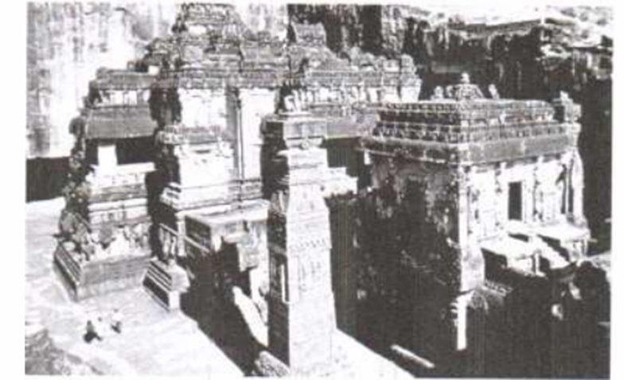  Look at the figure given above. Identify and name this structure.  A. Dashavtara VishnutempleDeogarh.  B. Terracotta temple, Vishnupur  C. Sun temple, Modhera  D. Kailashnath temple, Ellora
NOTE: The following question is for the visually impaired candidates in lieu of Question number 5.
Who among the following was the composer of Prayaga Prashasti?
A. Banbhatta
B. Charak
C. Harisena
D. Surdas
6. | Which of the following scripts were deciphered by James Prinsep?  A. Bengali and Devanagari  B. Sanskrit and Prakrit  C. Brahmi and Kharosthi  D. Greek and Indo-Greek
7. | Consider the following statements regarding the Greek School of Art in the ancient period :  I. Images of Buddha and Bodhisattas were discovered based on the Greek models.  II. Images were found in cities like Taxila and Peshawar.  III. Indo-Greek rulers ruled in north-west India.  Which of the above mentioned statements are correct ?  (A) I and II  (B) II and III  (C) I, II and III  (D) Only I
8. | Which Persian ambassador visited the Vijayanagara Empire?
 | A. | Domingo Paes |  | B. | Nicolo de Conti
 | C. | Abdur Razzaq |  | D. | Duarte Barbosa
9. | Fill in the blank :  In the popular traditions of Vijayanagara the Deccan Sultans are termed as _______________.
 | A. | Narapati |  | B. | Ashvapati
 | C. | Gajapati |  | D. | Nayakas
10 | Find out the correct chronological order of ‘Bhakti Saints’ from the following options :  - Guru Govind Singh  - Meera Bai  - Kabir  - Guru Nanak  Options:
 | A. | I, II, III & IV |  | B. | II, III, IV& I
 | C. | III, II, IV &I |  | D. | IV, II, I & III
11. | Given below are two statements, one labelled as Assertion(A) and the other labelled as Reason (R). Assertion (A): Most Harappan sites are located in semi-arid lands.  Reason (R): Water reservoirs found at Dholavira may have been used to store water for Agriculture.
A. Both (A) and (R) are correct and (R)is the correct explanation of (A)
B. Both (A) and (R) are correct, but (R) is not the correct explanation of (A)
C.(A) is correct, but (R) is not correct
D. (R) is correct, but (A) is not correct
12. | Complete the following with the correct option:  Francois Bernier: French Traveller, Duarte Barbossa :  - Portuguese traveller  - Russian traveller  - Italian traveller  - British traveller
13. | Match List I with List II and select the correct answer using the codes given below in the lists:  A: A−2,B−4,C−1,D−3  B: A−3,B−4,C−1,D−2  C: A−2,B−1,C−4,D−3  D: A−3,B−1,C−4,D−2
  List I  (Leader) | List II  (Area Under their Operation)
  A. Maulavi Ahmed Shah | 1. Barrackpore
  B. Mangal Pandey | 2. Faizabad
  C. Bakht Khan | 3. Kanpur
  D. Nana Saheb | 4. Delhi
14. | Given below are two statements, one labelled as Assertion(A) and the other labelled as Reason (R).  Assertion (A): Burdwan Raja’s estates had been publicly sold, but he remained in control of his zamindari  Reason (R): East India Company allowed the Raja to maintain his zamindari under permanent Settlements.  A. Both (A) and (R) are correct and (R)is the correct explanation of (A)  B. Both (A) and (R) are correct, but (R) is not the correct explanation of (A)  C.(A) is correct, but (R) is not correct  D. (R) is correct, but (A) is not correct
15. | Identify which of the following was not correct in the context of the Mughal Empire.  A. State’s help was available for irrigation.  B. Jins-i-Kamil was a Rabi Crop.  C. Many new crops reached India such as maize, potato, etc.  D. There were two types of peasants-khud- Kashta and Pahi-Kashta
16. | Which of the following does not shed light on the Mughal agrarian history?  A. Ain-i-Akbari written by Abul Fazl  B. 17th and 18th century revenue records  C. Records of the East India Company  D. Humayun Nama written by Gulbadan Begum
17. | Which of the following statement(s) is/are incorrect regarding the Indian freedom struggle:
 | A. | Gandhiji withdrew from the non-cooperation movement due to the chauri chaura incident. |  | B. | Gandhiji gave his first public speech at BHU.
 | C. | Mahatma Gandhi was arrested in 1921 |  | D. | Nehru was the Congress president at the Lahore session.
18. | Consider the following events:  1. Introduction of Permanent settlement  2. American Civil war  3. Fifth report in the British Parliament  4. Santhals arrived in the hilly area of Rajmahal  The correct Chronological order of these events is:  A. 1, 2, 3, 4  B. 1, 4, 3, 2  C. 1, 3, 2, 4  D. 1, 3, 4, 2
19. | Which of the following is an incorrect match for the Centre of the revolt and their leaders?  (A) Gonoo- Kol tribals  (B) Kanpur-Nana Sahib  (C) Jhansi-Rani Lakshmi Bai  (D) Bihar-Shah Mal
20. | Which one of the following is associated with Objective Resolution?  - It proclaimed India to be an ‘independent Sovereign Republic’  - Safeguards shall not be provided for minorities  - Specific form of democracy was defined  - None of these
21. | Who among the following wanted the term ‘minority, to be interpreted as the economic term?  (A) N.G Ranga  (B) Jaipal Singh  (C) B.N Rao  (D) S. N. Mukherjee
 | SECTION B  SHORT ANSWER TYPE QUESTIONS |  |  |  |  |  | 3x6=18Marks
22. | ‘‘Many reconstructions of Harappan religion are made on assumptions.’’ Support the statement with examples.  OR  ‘‘Late Harappan settlement or ‘successor cultures’ indicate a return to rural way of life.’’ Support the statement with examples.
23. | Examine the notion of kingship that developed during the post- Mauryan period.
24. | India had a unique system of communication during the fourteenth century”. Examine the statement of Ibn Battuta.
25. | For what purpose were the halls of the Virupaksha temple used? What were the features of the chariot streets that existed in the temple complexes?
26. | Analyze the impact of cotton boom in India during the American Civil War.
27. | “The annexation of Awadh displaced not just the Nawab, but also dispossessed the taluqdars of the region, causing breakdown of an entire social order.” Critically examine the statement.  OR  Why did the British annex Awadh in 1856?
 | SECTION C  Long Answer Type Questions |  |  |  |  |  | 8x3=24
28. | “Mahabharata is a story based on kinship and social relations.” Support the statement with examples.  OR  “Historians consider several elements when they analyse texts. Explain such elements used to analyze Mahabharata. Why Mahabharata is considered to be a dynamic text?
29. | Describe caste and rural milieu of Mughal India. What was the role of the jati Panchayat in the rural society during Mughal period?  OR  Explain the organisation of the administration and army during the rule of Akbar as given in ‘Ain-i Akbari’.
30. | Explain why Gandhiji started the Salt Satyagraha? Why was it a notable event?  Or  “Wherever Gandhiji went rumours spread of his miraculous powers.” Explain with examples.
 | SECTION -D  Source Based Questions |  |  |  |  |  | 4x3=12
31. | Read the following source carefully and answer the following questions:  Why were Stupas Built?  This is an excerpt from the Mahaparinibbana Sutta, part of the Sutta Pitaka. As the Buddha lay, dying Ananda asked him “What are we to do Lord, with the remains of the Tathagata (another name for the Buddha)?” The Buddha replied, “Hinder not yourselves Ananda by honouring the remains of the Tathagata. Be zealous, be intent on your own good.”  But when pressed further, the Buddha said, “At the four crossroads, they should erect a thupa (Pali for stupa) to the Tathagata. And whosoever shall there place garlands or perfume…. or make a salutation there, or become in its presence calm of heart, that shall long be to them for a profit and joy.”
 | 31.1. Why were the stupas built?  31.2. What Asoka did with the relics of Buddha?  31.3. Describe the structure of the stupas. |  |  |  |  |  | 1  1  2
32. | The given source carefully and answer the questions that follows:  A church in Khambat  This is an excerpt from a farman (imperial order) issued by Akbar in 1598: Whereas it reached our eminent and holy notice that the padris (fathers) of the Holy Society of Jesus wish to build a house of prayer (church) in the city of Kambayat (Khambat, in Gujarat); therefore an exalted mandate … is being issued, … that the dignitaries of the city of Kambayat should in no case stand in their way but should allow them to build a church so that they may engage themselves in their own worship. It is necessary that the order of the Emperor should be obeyed in every way.
 | 32.1. What was the farman? |  |  |  |  |  | 1
 | 32.2. From whom did the king anticipate opposition? |  |  |  |  |  | 1
 | 32.3. What light does this throw on the religious policy of the Mughals? |  |  |  |  |  | 2
33. | Read the following source carefully and answer the questions that follow:  “There cannot be any divided loyalty”  Govind Ballabh Pant argued that in order to become loyal citizens people had to stop focusing only on the community and the self.  For the success of democracy one must train himself in the art of self discipline.  In Democracies one should care less for himself and more for others. There cannot be any divided loyalty. All loyalties must exclusively be centred round the state. If in a democracy, you create rival loyalties, or you create a system in which any individual or group, instead of suppressing his extravagance, cares nought for larger or other interests, then democracy is doomed.
 | 33.1. Why did Govind Ballabh Pant lay more stress on the art of self-discipline?  33.2. What was considered important for the success of democracy?  33.3.‘In Democracies one should care less for himself and more for other.’ Give your views on this philosophy. |  |  |  |  |  | 1  1  2
34. | SECTION-E  MAP BASED QUESTION 1x5=5
34.1 | On the given political outline map of India, locate and label the following with appropriate symbols : 1+1+1=3  a) Bodhgaya- where Buddha attained Enlightenment  b) Kalibangan- A mature Harappan site  c) Gandhara- Mahajanapada during 6th century BCE  OR  Chauri Chaura
34.2 | On the same outline map of India, a place related to the centres of the Revolt of 1857 is marked as A and B. Identify it and write its name on the line drawn near them. (2)
Note: The following questions are for the Visually Impaired Candidates only in lieu of Q.No.34
(34.1) Mention any two sites of the matured Harrapan period.
(34.2) Mention any one Territory under Mughal empire.
OR
Name the capital of Vijayanagar empire.
(34.3) Mention any two centres of the Revolt of 1857.


34.
History Map
NAME: | CLASS/SEC:
ROLL:

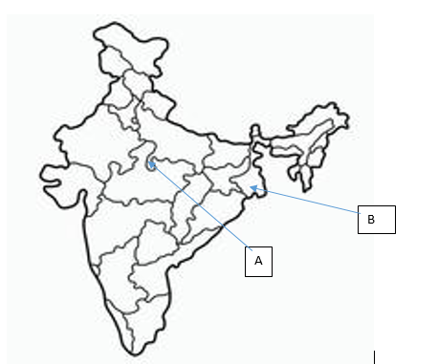

34.
NAME: CLASS/SEC: ROLL NO:

